COMP-385

**Tennessee to Tennessee**

**Given** a user on the loan products screen creating a quote in the branch state of TN for a TN resident with a loan amount greater than $1,500 and less that $5,000.  
**When** the user hits the “see product” button  
**Then** the loan quotes is created for alpha type R01 with Agreed rat 35.99% or less.

**Tennessee to Arkansas**

**Given** a user on the loan products screen creating a quote in the branch state of TN for an AR resident with a loan amount greater than $1,500 .  
**When** the user hits the “see product” button  
**Then** the loan quotes is created for alpha type R05 with Agreed rat 35.99% or less.

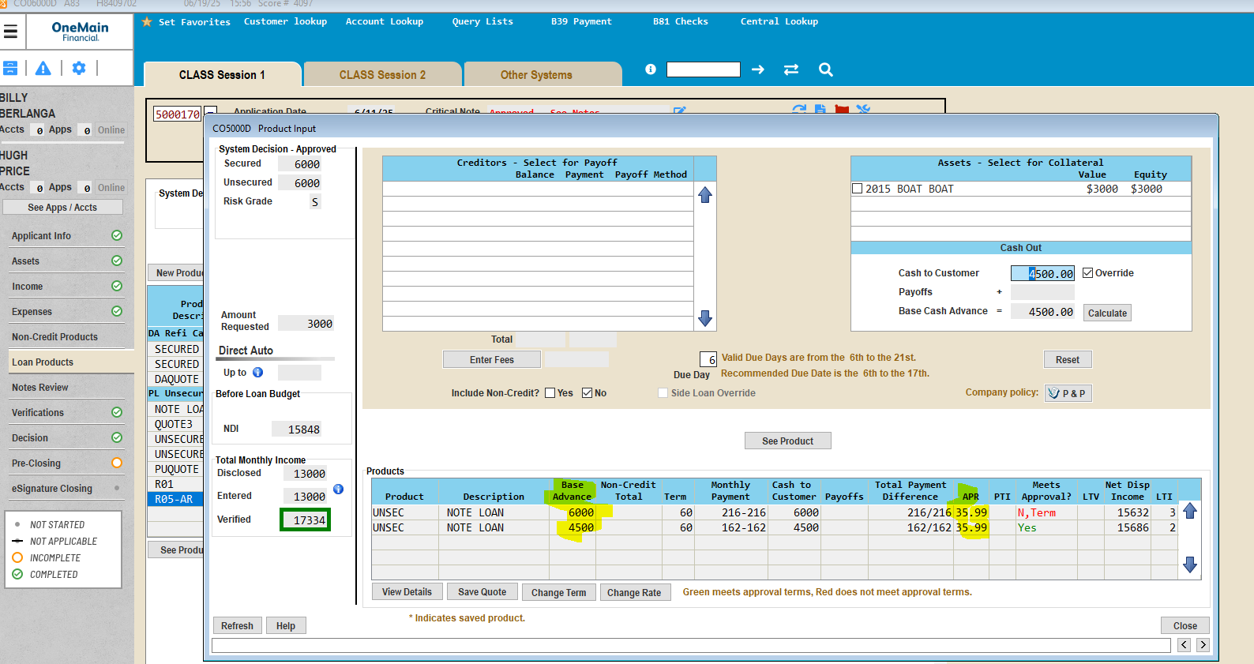

**Tennessee to Georgia**

**Given** a user on the loan products screen creating a quote in the branch state of TN for an GA resident with a loan amount greater than $3,100 .  
**When** the user hits the “see product” button  
**Then** the loan quotes is created for alpha type H01 with Agreed rat 35.99% or less.

**Georgia to Tennessee**

**Given** a user on the loan products screen creating a quote in the branch state of GA for a TN resident with a loan amount greater than $3,100 and less that $5,000.  
**When** the user hits the “see product” button  
**Then** the loan quotes is created for alpha type K01 with Agreed rat 35.99% or less.

**Given** a user on the loan products screen creating a quote in the branch state of GA for a TN resident with a loan amount greater than $5,000 .  
**When** the user hits the “see product” button  
**Then** the loan quotes is created for alpha type K01 with Agreed rat 35.99% or less.

